December 2, 2015

IMPORTANT DATES:
12/4 All Pro Dads 8:20 12/10 ZHS Jazz Band visits campus 12/14-17 Mid Year Ceremonies (specifics TBA) 12/18 SAC Meeting 12/21/15-01/04/16 Winter Holiday
UPCOMING DATES: 01/05 Students Return 01/14 End of Quarter 2 01/15 Teacher Planning Day-no school 01/18 Dr. ML King Holiday-no school
Principal’s Pen
It's hard to believe that we are well into the second quarter! We will be half way through the school year before we know it! The students' academic achievement continues to be our primary focus. One of the ways we are helping to promote academic achievement is through a school wide reading goal. If our students read 50,000 books by the end of the school year, Mrs. Boeger and I have agreed to do something wacky! The students will get to determine exactly what that is! Stay tuned! This should be interesting!
Please also remember how beneficial I-Ready is for students' academic growth. Here at school we "strive for 45." That means, we want students to spend at least 45 minutes working in I-Ready Reading as well as in I-Ready math. If you have internet access, please encourage your child to work on the program at home to build skills in reading and math.
I would like to take a moment to say how very appreciative we are of our community partners and their generous spirit toward our school and families, especially during the holidays. Many of our business/community partners donate food, clothing, and gifts to families in need. We are so grateful for their thoughtfulness!
We are also grateful for our hard working staff, students, and families at WZES. Thank you for supporting our efforts to ensure our students achieve great things! We hope you and your family have a happy winter holiday!
Mrs. Tidd Principal, WZES

Warmest Regards,

Charlene Tidd

Principal, WZES

Bulldog Spotlight November Chamber of Commerce Citizen of the Month:
Jennifer Delcastillo
WZES November Super Kiwanis Kids
November honorees were nominated by their teachers for this recognition, which is hosted each month by the Zephyrhills Kiwanis Club.

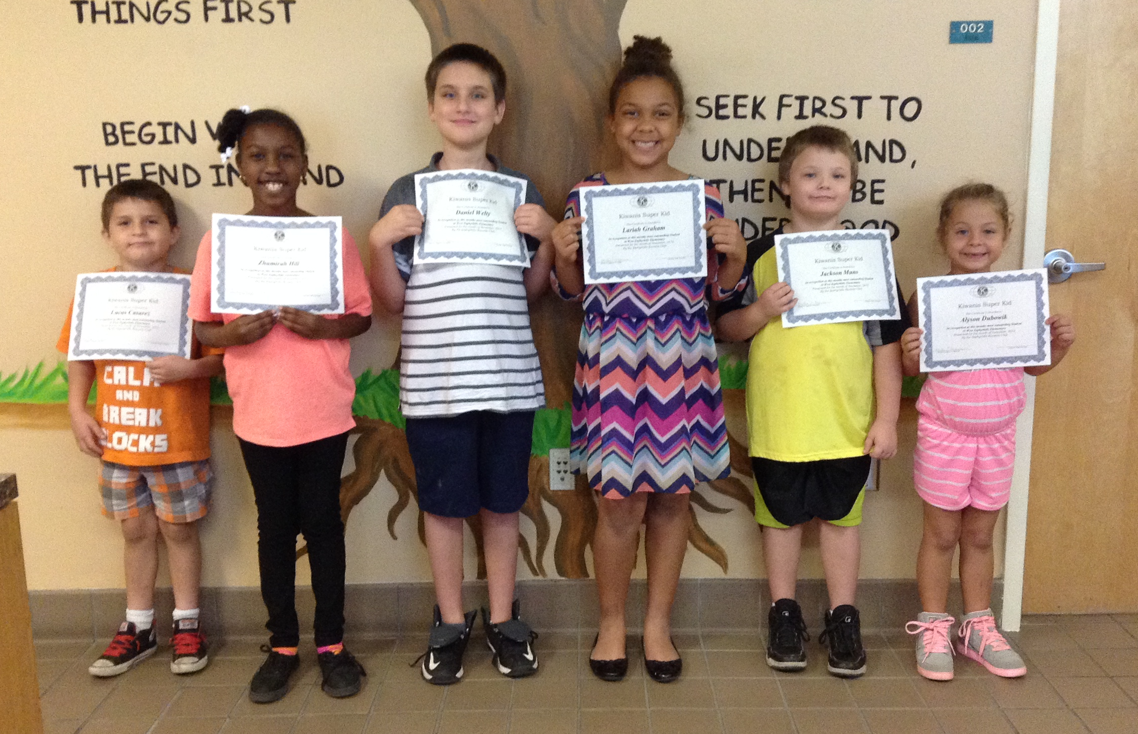
Lucas Casarez * Zhamirah Hill
Daniel Welty * Lariah Graham
Jackson Mums * Alyson Dubowik

Clinic Updates With 850 students on campus our clinic gets very busy during the school day. We want to be able to give every student in the clinic our full attention. We have had many “accidents” or clothing spills lately so we need your help. Send a full change of clothing with your K-2 grade student for those occasional spills. Keeping this set in the backpack or classroom saves a student a trip to the clinic.
School Advisory Council ARE YOU THE ONE? We are still looking for community members, parents, and/or business partners to join our School Advisory Council. Meetings are one Friday, each month from 7:30-8:30 a.m. Please call Mrs. Tidd at 794-6300 if interested.
Leader in Me-Leader Spotlight Our WZES students continue to build their leadership skills. In November, three students and Ms. Buckler and Ms. Prather (not in photo), planned questions and met with job applicants at the Pasco School District Job Fair. Our students brought along their Leadership Notebooks to share.
Another WZES Leader, Austin John, shown below with his mom, teacher LeAnne John, was very impressive at the Great American Teach-In last month as he taught his classmates about his heifer, Carly, and his plans to start his own herd of cattle. Austin is a member of the Pasco County Junior Cattlemen and 4H.
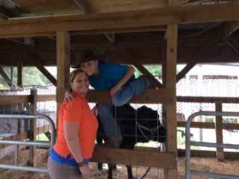
SNIP & CLIP:
Don't forget, each class that brings in 500 Box Tops by December 11, will get an ice cream party. YUM! Keep on clipping!
Congratulations! WZES fifth grader, Jenny Delcastillo, in Mrs. Gray’s class, won third place in the 2015 Clerk & Comptroller Constitution Essay Contest. Hers was one of 82 entries from across the entire school district. We are proud of Jenny for this recognition! Jenny was also recognized as our November Citizen of the Month.
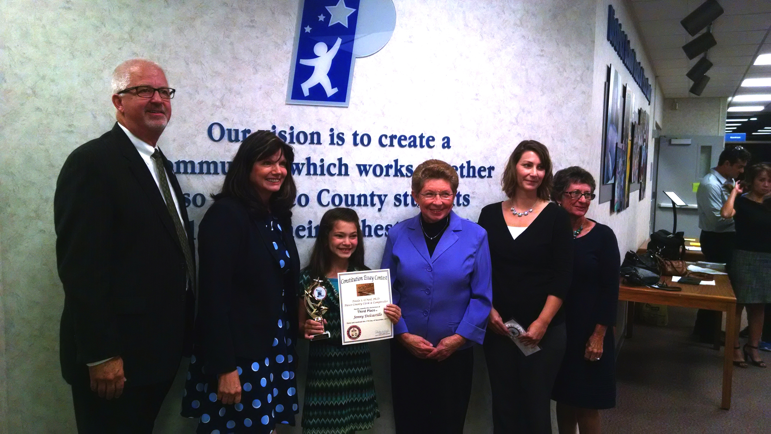
Best Wishes, but not Goodbye!
We have several staff members retiring this year and while we will miss them, we also congratulate them on a well-deserved recognition. Pictured here are Mrs. Becky Bishop, our Parent Involvement Coordinator, and Mrs. June Maniscalco, our Clinic Assistant. Both ladies served their last day on November 30, after three decades of service to our school and community. Thank You, June and Becky!
Parent Reminders
- Please remember that flowers and helium balloon deliveries are not permitted on campus for students.
- Bus riders may only ride their assigned bus.
- Pasco County LEA Parent Involvement Plan, WZES PIP, and the WZES School Improvement Plan are housed in the front office and are available for your review.
WZES PTA News
Thank you again to all parents and staff who have become members of WZES PTA. We continue to encourage everyone to become part of Your WZES PTA, at a cost of only $6.00 per family for the school year. Also, if you are interested in becoming involved, we welcome any help with the many activities sponsored by Your WZES PTA. You may contact Jessica Boydston, President, at 813-794-6300.

COOL! Fourth Grade Project
We are quickly approaching the Winter Break and would like to invite you to take part in a Giving-to-Others project that will help children in our community receive a gift for the holidays. If you have any toys that are not damaged or dirty, please bring them to school, by December 17. They will be donated to the Neighborhood Care Center, where they will be wrapped and given to families in need.
Thank you, in advance, for helping to make a child’s holiday memories brighter!
Please Help Us Reach Our Reading Goal!
Our school wide reading goal for this year is to read 50,000 books! WOW! You can help us to meet our goal by setting aside a time for reading each evening at home. Also, talk to your children about the books they are reading. We are trying to instill a love of reading here at WEST! Look for more information from your child’s teacher in the coming weeks.
READ! READ! READ! To LEAD! 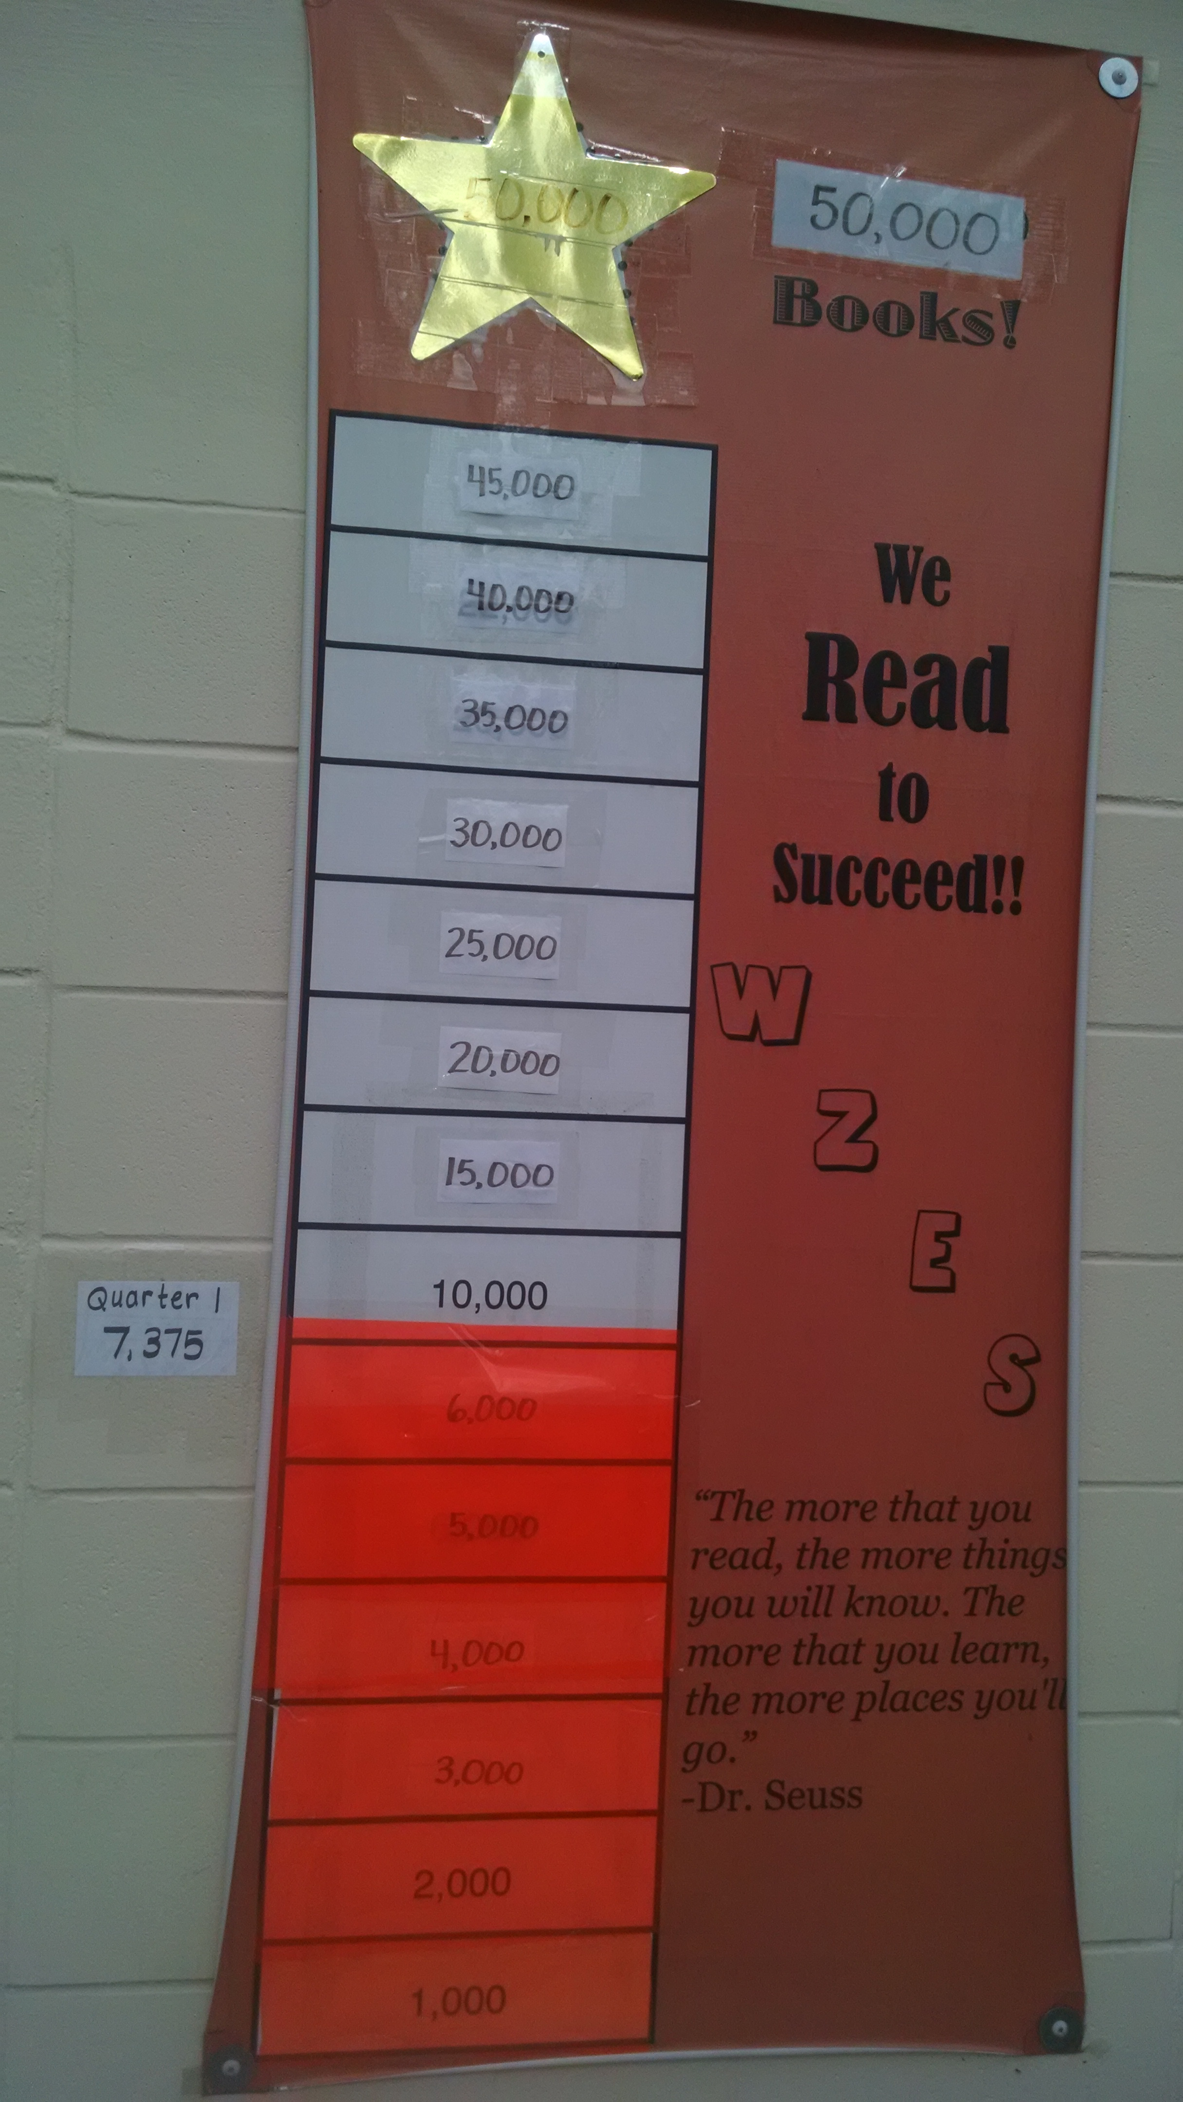

Pasco Parent Press Check out the Superintendent’s parent newsletter at this link:
http://www.pasco.k12.fl.us/ppp/112015
Recycling Earth Patrol is Teaming up with MARS!
Bring your old electronics to school during regular school hours and the Earth Patrol will send them to MARS!—a Materials
Recycling center. Instead of sending them to the landfill, your electronic devices will be recycled 100%!! Nothing is wasted!! We have a large cardboard box in the back of the school waiting for your old electronics!
Our battery recycling efforts continue to add up. As of October’s most recent information WZES has the MOST recycled batteries in the entire district! Way to go Bulldogs!

Nine-Mile War Enthusiasts! Bulldogs beat the Pirates!
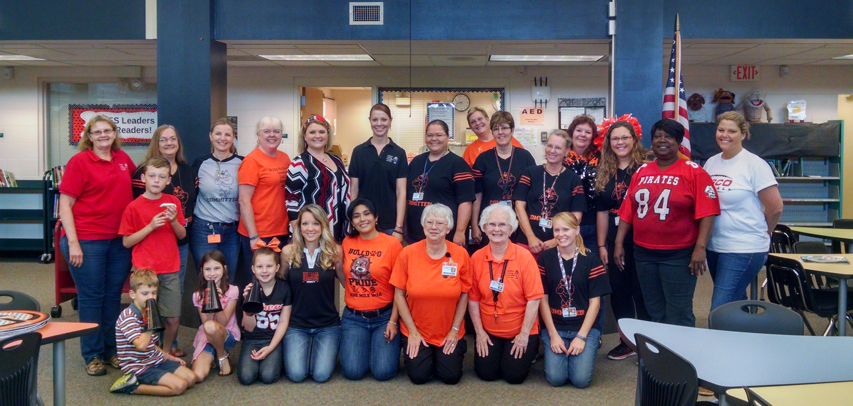

Superintendent: Kurt Browning
School Board Members:
Allen Altman
Cynthia Armstrong
Alison Crumbly
Joanne Hurley
Steve Luikart

SANTA CLAUS IS COMING TO TOWN!
Breakfast with Santa AT WZES! Sponsored by the Pilot Club of Zephyrhills – Saturday, December 5, 2015, from 9 to 11 AM in our school cafeteria. Cost is $5 per person. Enjoy a hot breakfast with beverage and a dance performance by Peggy’s Dance Place. Bring your own camera to take a picture with Santa!

FREE PHOTOS with SANTA--Saturday the 5th!
Free photos with Santa will be available, courtesy of The Price Family of Goin' Postal at 38439 5th Avenue, during the Festival of Lights celebration from 2 to 9 p.m. on Saturday, December 5 in Downtown Zephyrhills. The family has provided free photos with Santa for over 10 years as a gift to the community. The Prices also designed and built a custom-made "Santa's Workshop" parade float which features the man in red as the star of the lighted nighttime parade which begins at 6 p.m.
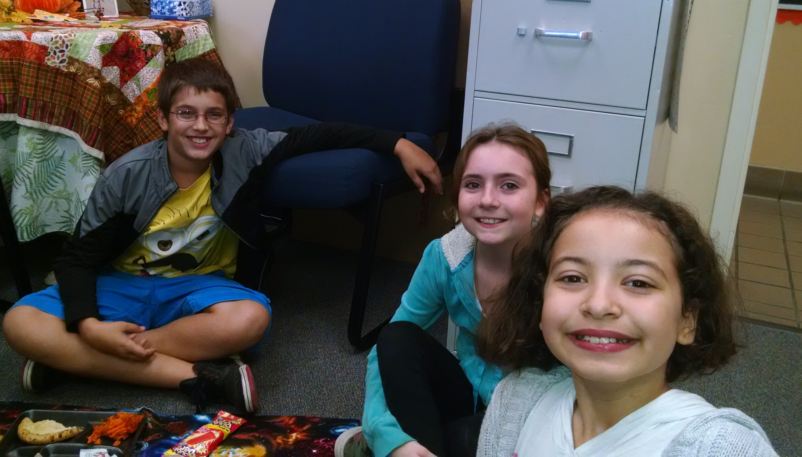
Three fifth graders enjoyed a lunch picnic in the AP’s office because they are all around great kiddos! Who will it be for December?
RELAY FOR LIFE Hugs!!
Starting on Friday, December 5, from 9:00-9:30, students are invited to come and make a donation of 50 cents to get a Beanie Baby. These will be available only on Fridays in Mrs. Bacot’s classroom. Thank you, in advance, as all donations will support our Relay for Life team.
Great American Teach-In
WZES would like to thank the many fine folks who visited our campus during Great American Teach-In week. Teacher, LeAnne John, organized many visitors who brought their ‘grown-up toys” to share with our students. Students saw the workings of a garbage truck and got to honk the horn. Some visited our Ag barn to learn about a classmate’s heifer and work with cattle. Others saw a pig and learned how to take care of pets while some learned about nursing or other great careers.
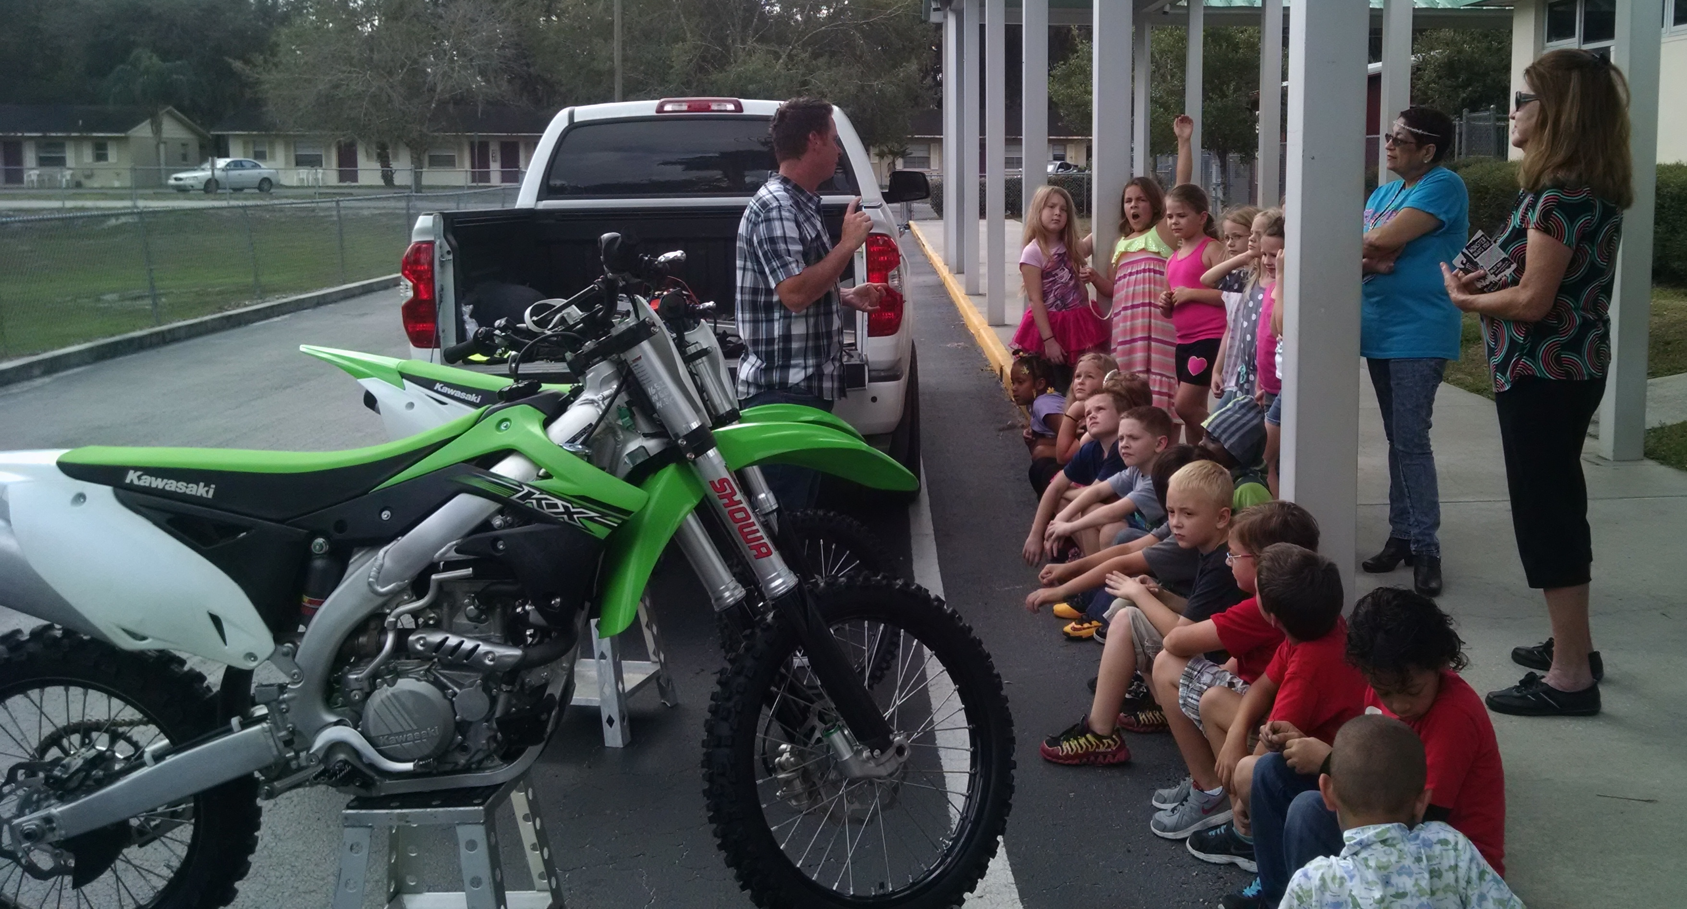
Mr. Tim Ferry and his motorcycle.
Pie in the Face for WZES!
On November 6, employees of the Southeast Bus Compound took a pie in the face to raise money for WZES. We thank them for their $100.00, donation to our WZES ABC fund.
Area Manager, Jesse Wilson and Field Service Specialist, Andrea Rowe—How Sweet!
Bulldog Blog: December 2015 By Mrs. Boeger, WZES AP SOME NEW FACES ON CAMPUS
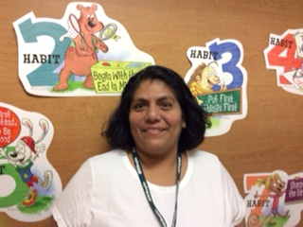
Have you ever heard the phrase, “When it rains it pours!”? Well, in terms of staff changes at WZES this month, we have had a monsoon! And while we will miss those who left who are very dear to our hearts, we always have room in our hearts for new folks! Let me introduce our new staff members to you. In September, Ms. Tashalyn Causey joined us as our lunchroom monitor. She helps our students be safe and remember to use their best manners while at lunch every day. Say hello to Ms. Causey the next time you visit campus for lunch with your child. Ms. Elena Rodgers joined our staff just last month and already she is building some great relationships with our students. Say hello to her in the cafeteria or around campus where she helps mentor our students into leaders! We said goodbye to our long-time school secretary, Ms. Joanie Sanzo, who took a new job last month at our district office. We are so glad we were able to welcome a familiar face, Ms. Cammie Wilkerson. to replace her in the front office. In the clinic we have hired Ms. Evelyn Navarro, who is replacing Ms. June Maniscalco who retired. Ms. Navarro is new to our area so be sure to welcome her and tell her how great it is to live in Zephyrhills! Finally, our last new addition to the front office is Ms. Meranda Sutton, as the new Parent Involvement Coordinator. She replaces Ms. Becky Bishop who also retired. Ms. Sutton is currently a substitute teacher and will be familiar to many families in Zephyrhills. We are glad she was able to transition to this role and will start in January. Have a great New Year!

